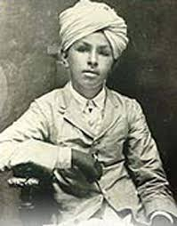
Name: Bhagat singh Class:8th Class no: 18 Conduct: A
Subjects | Grade | Extra-curriculum
English | A | Weapon knowledge
Mathematics | A | poetry
History | A* | Athlete
Physical Education | A* | Debating
Science | B
Journalism | A*
Geography | C
Chemistry | A
Literature | A*

Class Teacher’s comment:
*Bhagat Singh is very good at communicating with new people.
*He is always asking others to do the right thing and he is very focused on every task.

Principal’s comment:
*He is mostly involved in school’s political decisions, his advice always works and I would recommend him to run for school’s cabinets.

Achievements:
*Champion in debating and poetry
*1st runner up in archery and athletics
Class Teacher’s Signature: Principal’s Signature:

