“It needs loud explosions to make the deaf hear”….Bhagat Singh researched by: Nimratpal kaur
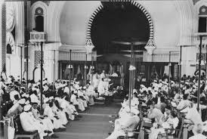
This all started when British government was planning to pass Public safety bill and Trade dispute Act in Central Legislative assembly. These bills gave more power to British government and police against freedom fighters like Bhagat singh. Indian people would’ve been getting tortured if someone didn’t tried to protest against the british government. Bhagat singh and Batukeshwar Dutt were the only one who were involved in revolutionary activities previously and the wanted India to have freedom from Britian. Therefore, they considered all the things happening and made a plan which was to throw two bombs in the central legislative assembly without hurting anyone to make the government hear them. Finally, the day arrived. It was 8thapril,1929, a day which we can never forget. Bhagat singh and Batukeshwar Dutt successfully threw two bombs in the assembly. While the bombs were blasting, the two young men were shouting out slogans “Inquilab zindabad!”(long live the revolution). They threw pink leaflets into the assembly hall which said “It needs loud explosions to make the deaf hear”. The bombs, as planned, did not harmed or killed anyone. A police officer was walking up to Bhagat Singh and Batukeshwar dutt . Bhagat singh was playing with his gun due to which the police officers got scared from Bhagat Singh. He placed his gun on the table. Both of them did not tried to escape, even though they had a chance to. But instead, they were standing bravely and shouting out slogans. They were arrested. Getting arrested was also a part of their plan. They planned that after they got arrested, they will make each and every Indian wake up and face the fear, they became inspiration of Indians.

